Project Design Phase-II Technology Stack (Architecture & Stack)

|  |  |
| --- | --- |
| Date | 28 June 2025 |
| Team ID | LTVIP2025TMID28937 |
| Project Name | Cafeteria menu display |
| Maximum Marks | 4 Marks |

Technical Architecture:

The Deliverable shall include the architectural diagram as below and the information as per the table1 & table 2 **Example: Order processing during pandemics for offline mode Reference:**[**https://pratapsharma.com.np/architecture-of-food-delivery-app/**](https://pratapsharma.com.np/architecture-of-food-delivery-app/)

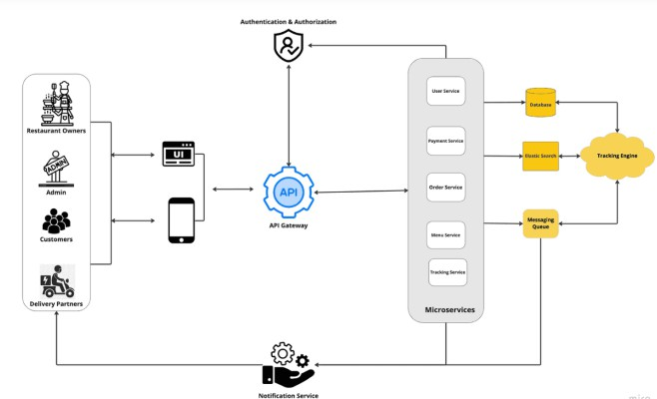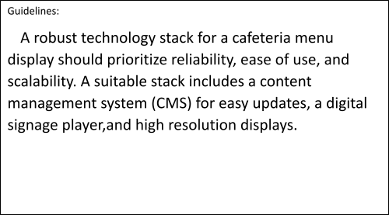

Table-1 : Components & Technologies:

|  |  |  |  |
| --- | --- | --- | --- |
| **S.No** | **Component** | **Description** | **Technology** |
| 1. | Cafeteria Menu Table | Stores meals, dates, descriptions, meal types. | Custom Table in ServiceNow |
| 2. | Fields | Eg:Date,meal type,menu items,calorie | servicenow table fields |
| 3. | Data Model | ServiceNow Data Dictionary | Field types, choice lists, references |
| 4. | Form Validations | Validate inputs (e.g., required fields, future dates only) | UI Policies, Client Scripts |
| 5. | Data Processing | Server-side querying and data logic | GlideRecord, Script Includes |
| 6. | Auto-Populate/Expire | Automate weekly updates or cleanup of old menus | Scheduled Jobs, Business Rules. |
| 7. | Access Control | Secure who can view/edit the menu | ACLs (Access Control Rules). |
| 8. | Admin Interface | Internal ServiceNow UI for cafeteria staff | Form Layout & List View |
| 9. | User Display | For employees to view the menu via portal | Service Portal Widget (AngularJS) |
| 10. | UI Page | Jelly / UI Script / HTML | Custom display page inside classic UI |

Table-2: Application Characteristics:

|  |  |  |  |
| --- | --- | --- | --- |
| **S.No** | **Characteristics** | **Description** | **Technology** |
| 1. | Modular & Scoped | Self-contained, upgrade-safe application within ServiceNow | Scoped Application, Studio IDE |
| 2. | Role-Based Accessibility | Different access for Admins and Employees | Roles, ACLs, UI Policies |
| 3. | Date-Driven Functionality | Menus linked to specific dates, with filtering | Date fields, List Filters, GlideRecord |
| 4. | User Interfaces | UI for Admins (form/list) and Users (Service Portal or Mobile) | Form View, List View, Service Portal Widget |
| 5. | Secure by Design | Prevent unauthorized viewing/editing of menus | ACL Rules, Field-level Security, UI  Policies |

References:

<https://nento.com/restaurant-menu-display/?source=SEO&keyword=restaurant_menu_display> <https://pratapsharma.com.np/architecture-of-food-delivery-app/>